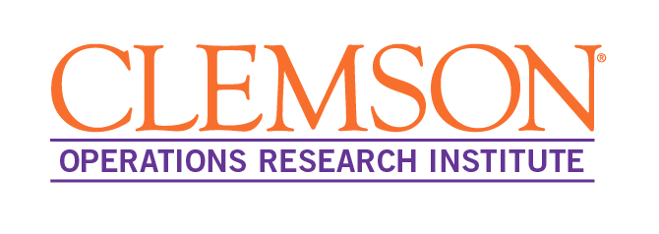

**Time**

Mon, April 10,   
11:15am – 12:15pm

**Location**

M103

Prof. Henry Wolkowicz is a distinguished mathematician who has made significant contributions to the fields of optimization, operations research, and mathematical modeling. He obtained his PhD in Mathematics from McGill University and completed a postdoctoral fellowship with Jon Borwein at Dalhousie University. In 1986, he joined the Department of Combinatorics and Optimization at the University of Waterloo, where he has been a professor ever since.

He is recognized as a leading expert in the field of SDP, and his research has been published in top-tier journals such as SIOPT and MOR. He has received numerous honors and awards, including being elected a Fellow of SIAM. He serves as a past and present associate editor of several leading journals, including SIOPT/MOR/INFORS/COAP/LAA. He has also served on the council/board of SIAM and ILAS. In addition to his research and service, he has authored several influential books, including the Handbook on SDP.

**About the Speaker**

(i) We first look at Strict Feasibility and Degeneracy in Linear Programming, LP. We show that if strict feasibility fails, then every basic feasible solution is degenerate. We study the theoretical and numerical ramifications of this result. We include an efficient preprocessing technique for facial reduction for strict feasibility.   
  
(ii) We then look at the best approximation problem to a polyhedral set, BAP. We exploit compact optimality conditions to obtain an efficient nonsmooth Newton method for BAP. We then apply a parameterized version to solve large scale LPs. The efficiency arises from applying sensitivity analysis. This results in a stepping stone external path following method, a simplex like path following method.   
  
Empirical evidence is provided for both parts of the talk.

**Abstract**

**New Views in Linear Programming on:   
(i) Degeneracy and (ii) Solving Large Scale LPs**

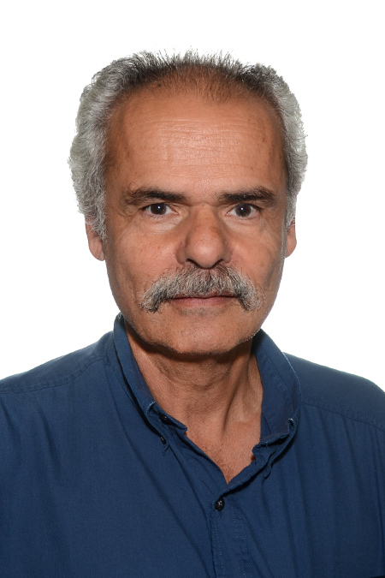

**Henry Wolkowicz**

Professor

Dept. of Comb. & Opt., Univ. of Waterloo

Operations Research Seminar