Wi-fi for University of Waterloo Guests
Note: Individual guest Wi-Fi access will timeout after 24 hours. However, guests attending a multi-day event will not be required to reconnect every 24 hours.
How to configure access for events (setup for event attendees)
- Under your computer's Wi-Fi settings, select 'uw-wifi-setup-no-encryption' from the list of available networks.
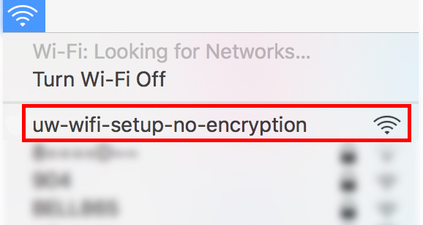
- In the Join 'uw-wifi-setup-no-encryption' pop-up window, scroll down and select the 'Click here if you are attending an event' option.
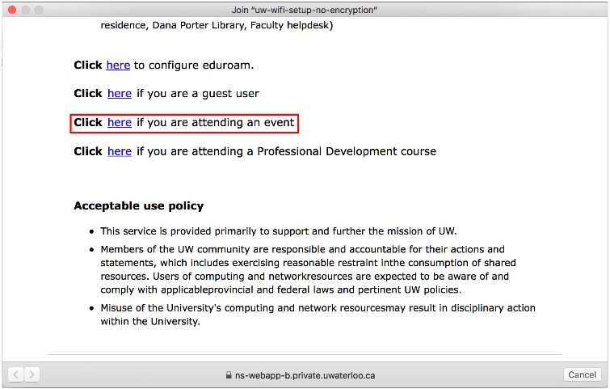
- Enter your first name, last name, email address, and password into each respective field. Click 'Submit' to connect your device.
